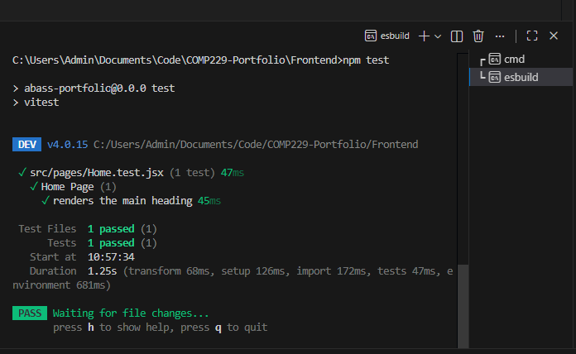
PARTI – Testing.
- • Perform unit testing on any of the components or page in your portfolio App.

- Provide the recording from AI cypress and the resulting code from the test and the snapshot
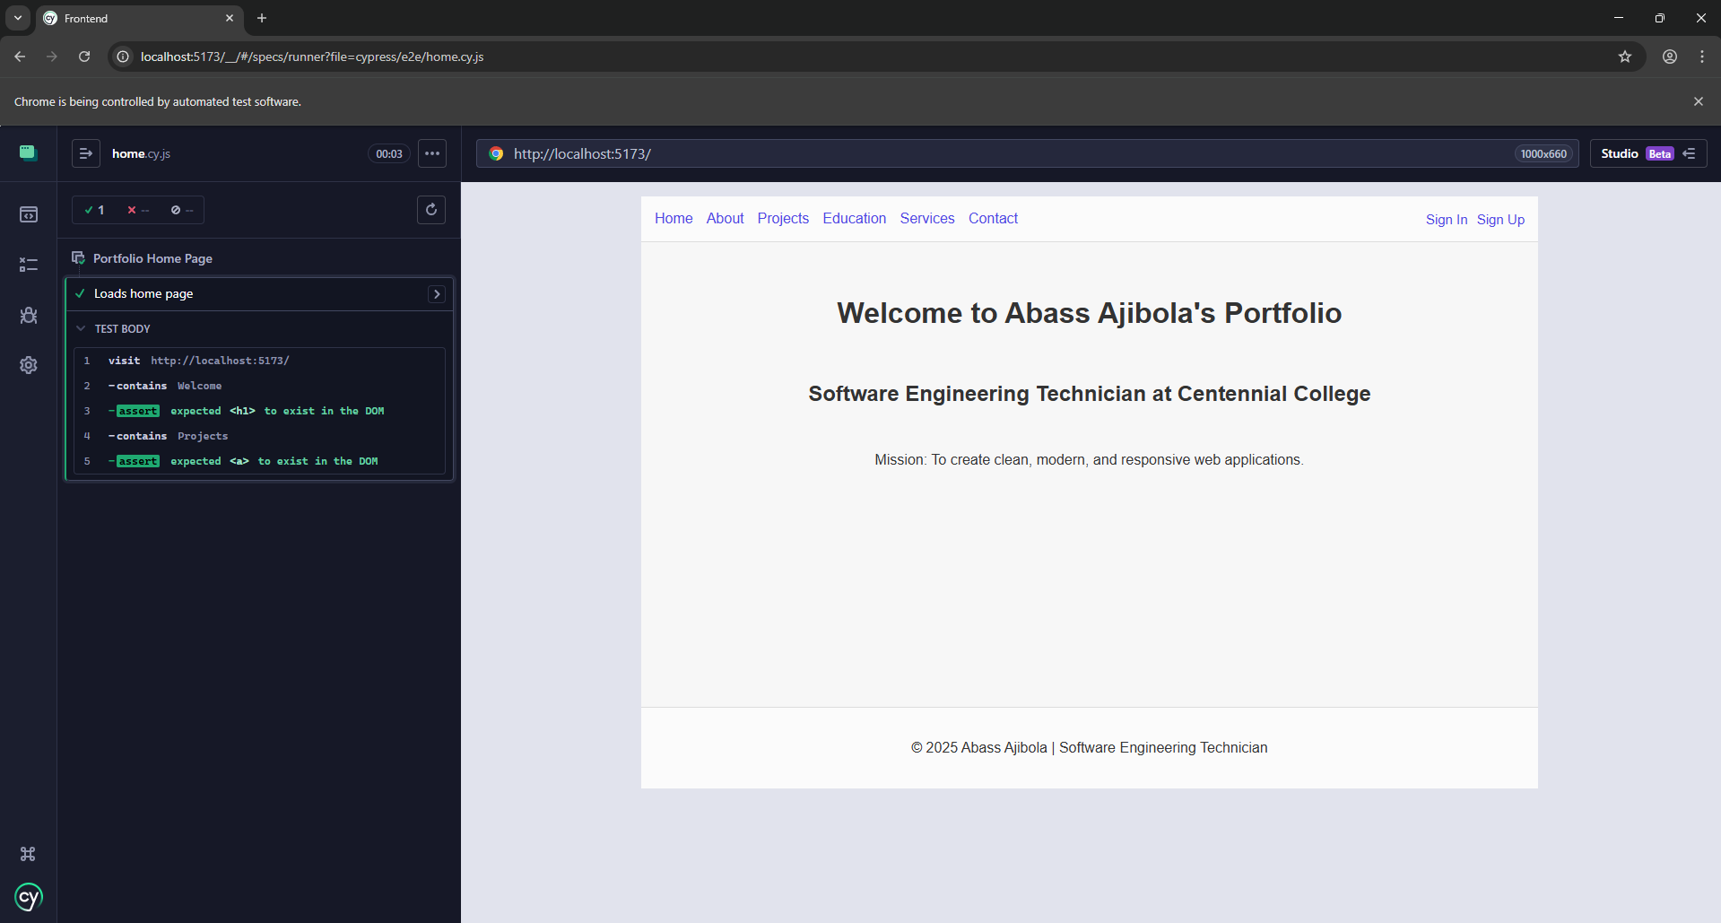

Resulting code from the test
describe("Portfolio Home Page", () => {
it("Loads home page", () => {
cy.visit("http://localhost:5173/");
cy.contains("Welcome").should("exist");
cy.contains("Projects").should("exist");
});
});

PART II – performance Optimization
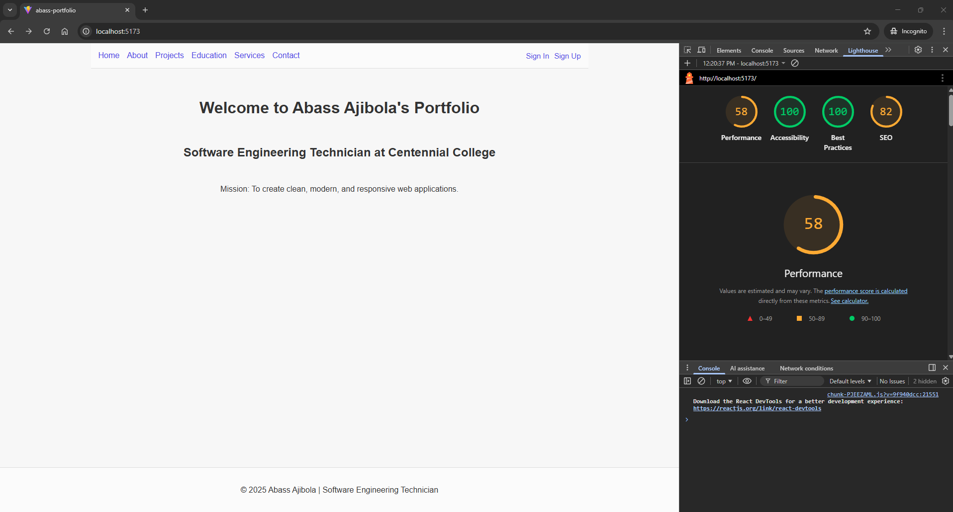

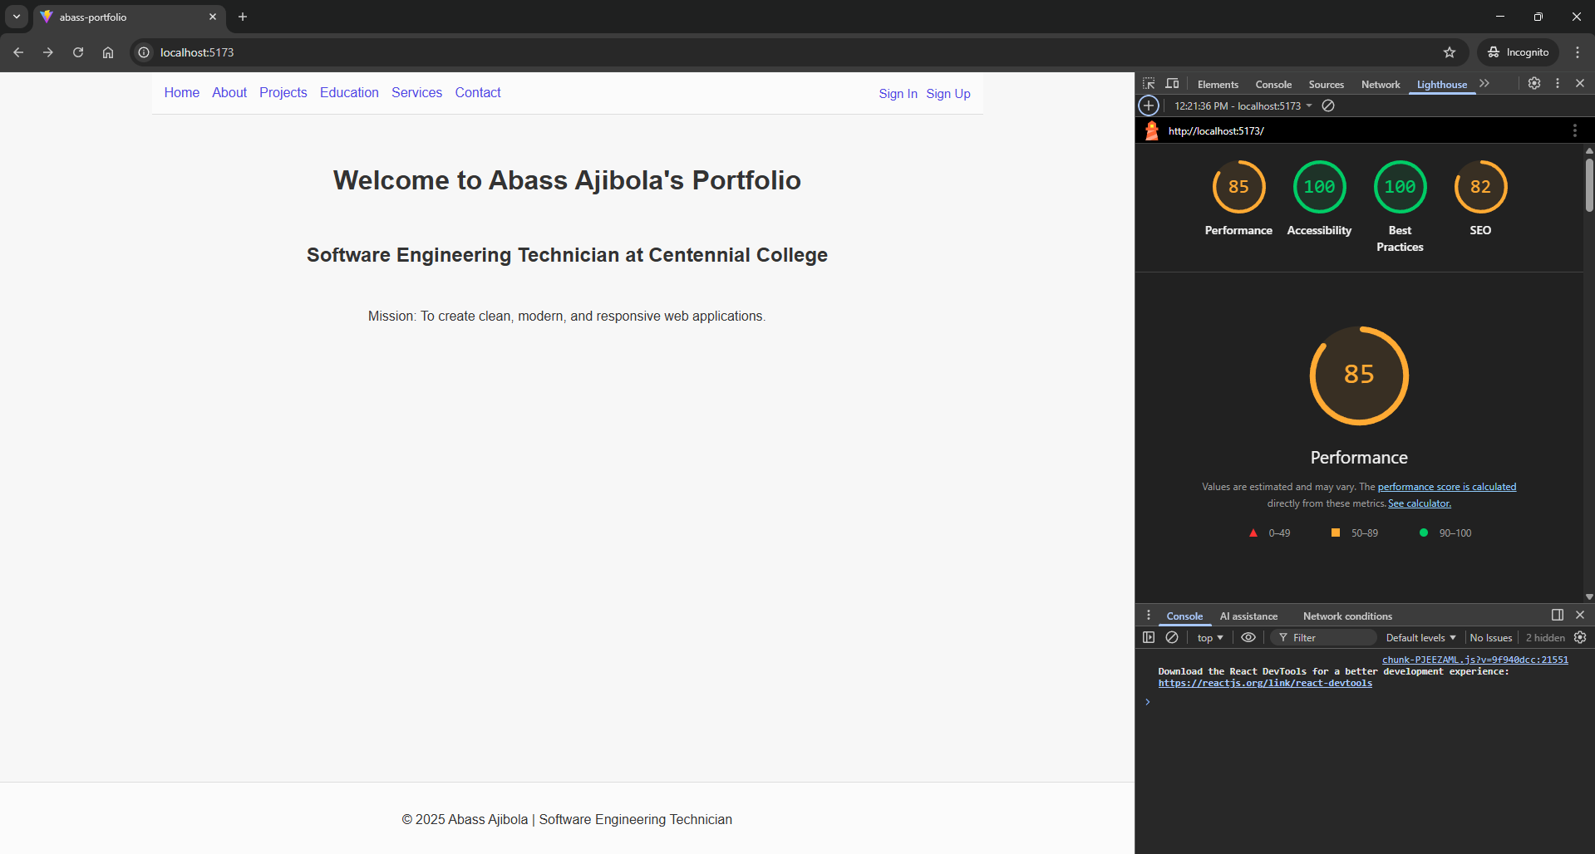
PART III – Deployment
https://comp229-portfolio-seze.onrender.com/
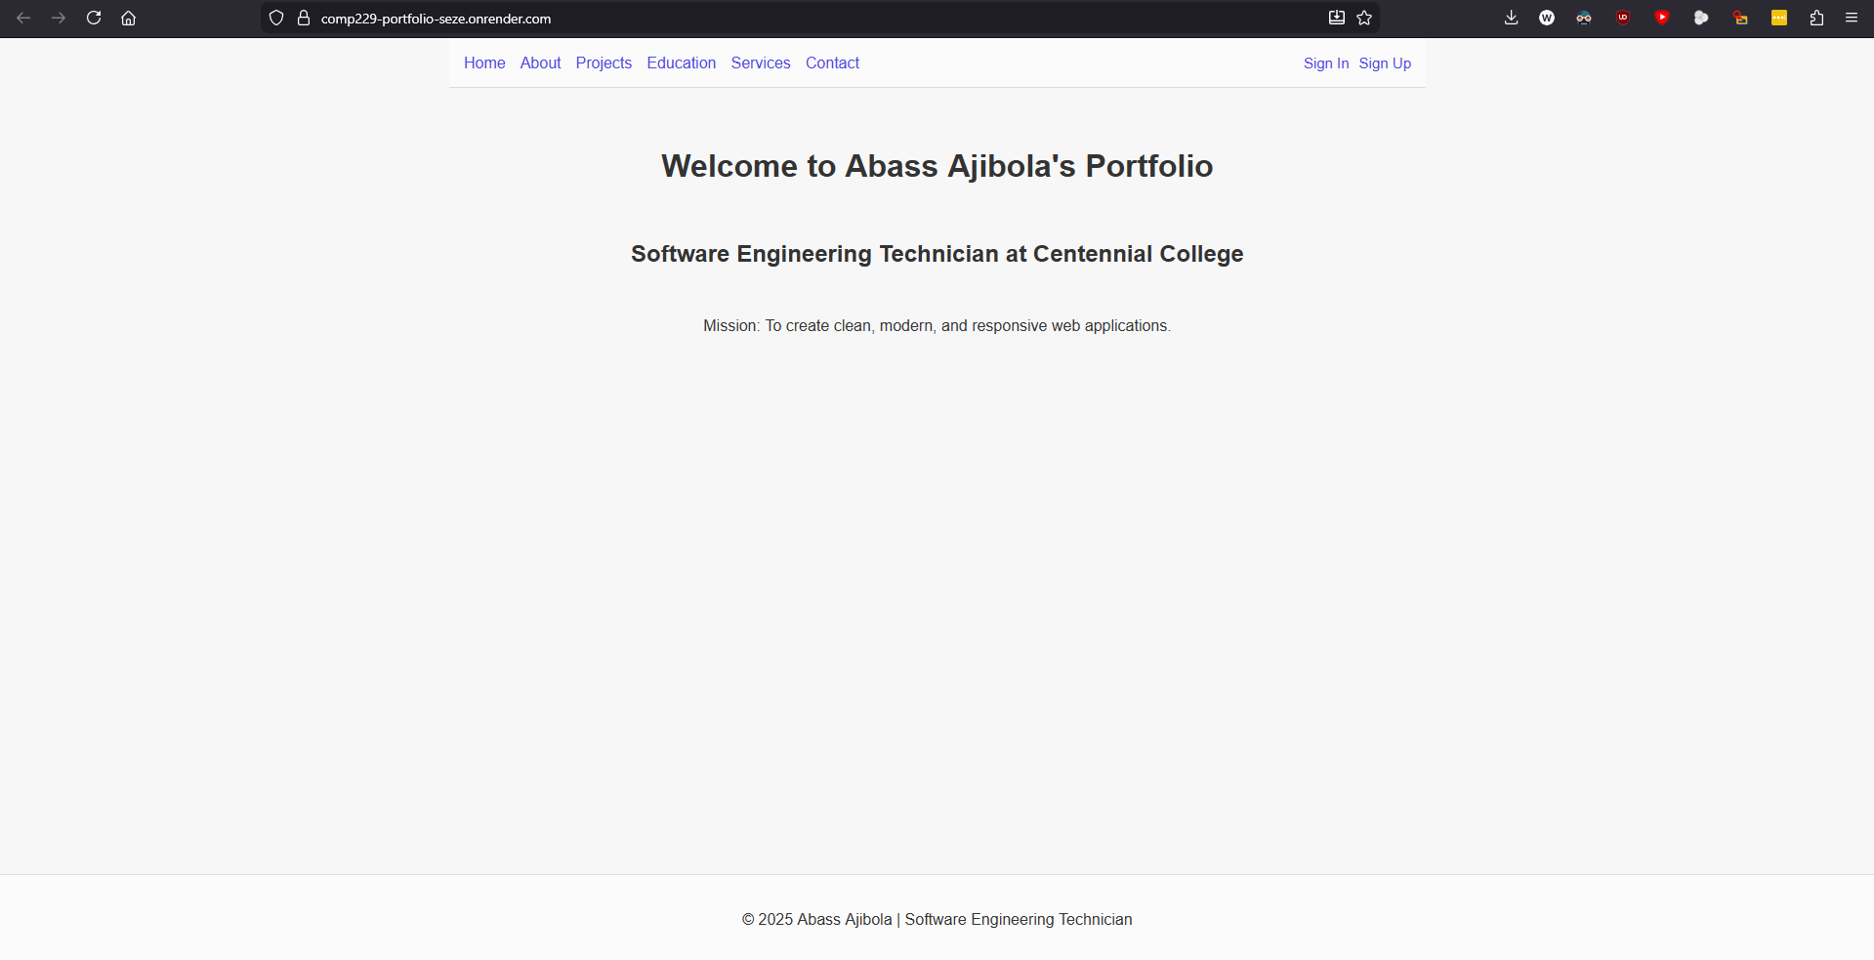

PART IV – CI/CD
Before update

